LOGIQUIDS PRACTICE TEST
Assessment 3 • Junior KG • 25 Questions
Name: ____________________ | Date: ______________ | Score: ______ / 25
How to answer: Look carefully at each question and draw a circle around the letter (A, B, C or D) of the correct answer. Parent can read the question aloud. Suggested time: 60 minutes.
Q1. What will come in place of "?" in the given series?
1-1, 2-2, 3-3, 4-4, ?
A 4-5 | B 5-5 | C 5-6 | D 6-6

Q2. What will come in place of "?" in the given series?
AB, CD, EF, GH, ?
A HI | B JK | C IK | D IJ

Q3. What will come in place of "?" in the given series?
2, 4, 6, 8, ?
A 9 | B 12 | C 11 | D 10

Q4. What will come in place of "?"
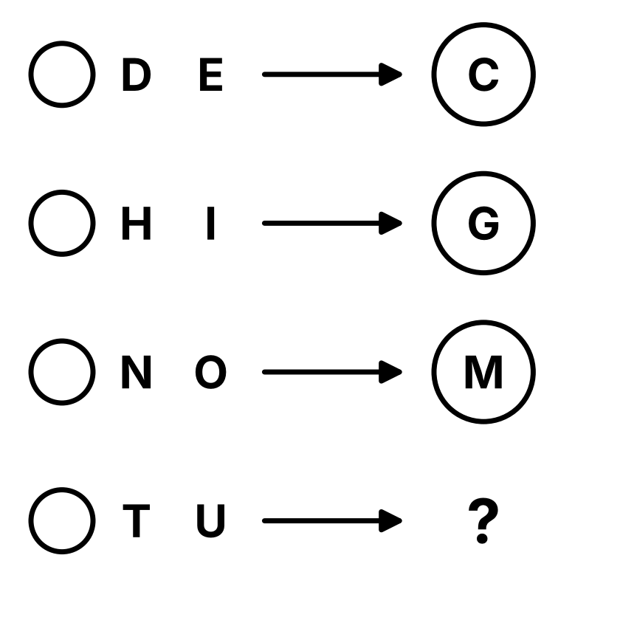
  A S | B V
  C R | D T

Q5. What will come in place of "?"
CAT → A
DOG → O
PIN → I
SUN → ?
A S | B N | C U | D A

Q6. What will come in place of "?"
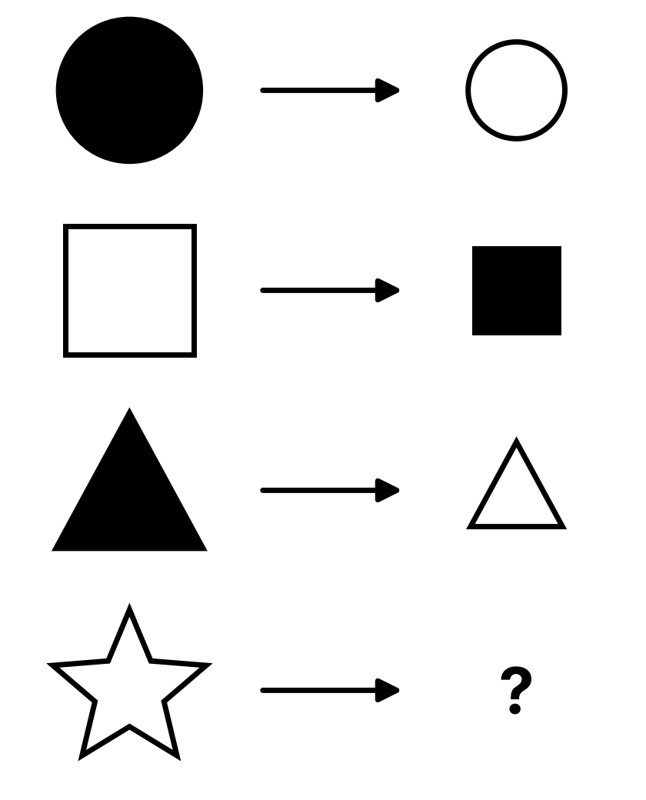
  A   | B  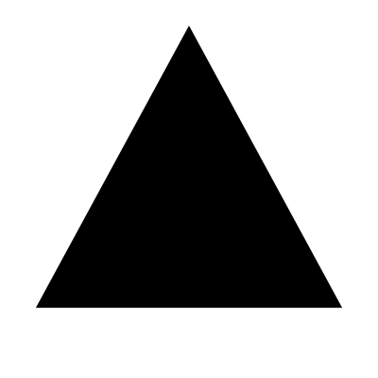
  C   | D  

Q7. What will come in place of the "?"
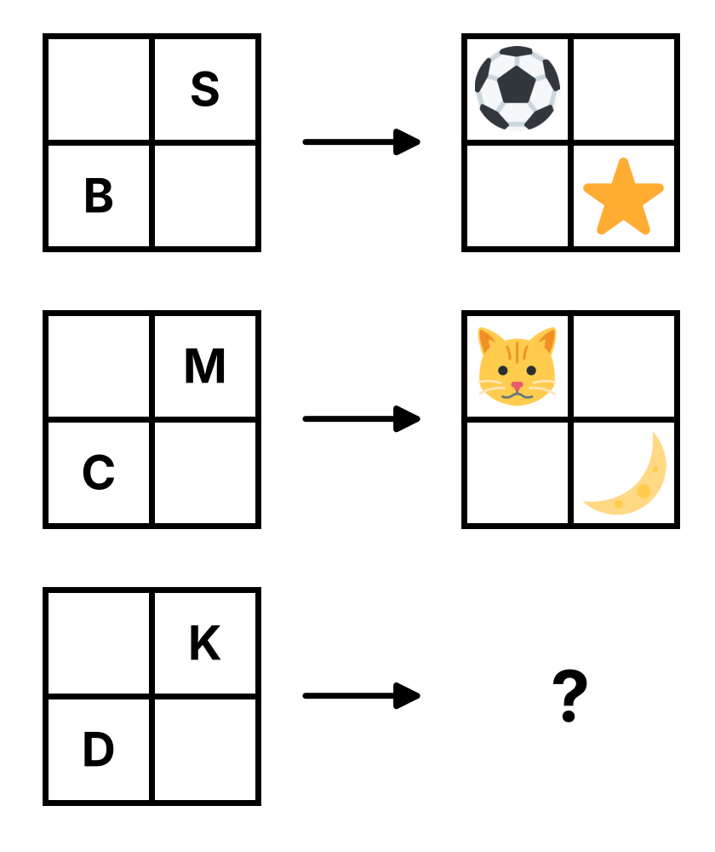
  A  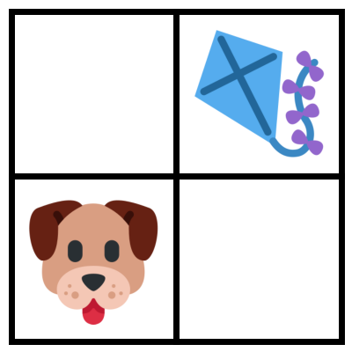 | B  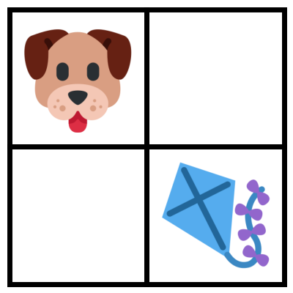
  C  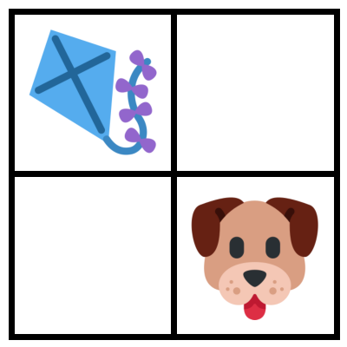 | D  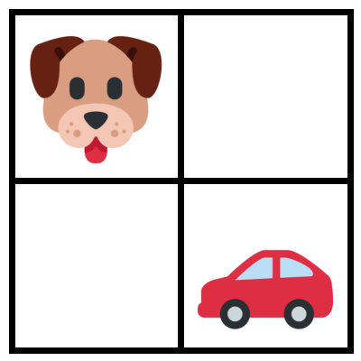

Q8. What will come in place of the "?"
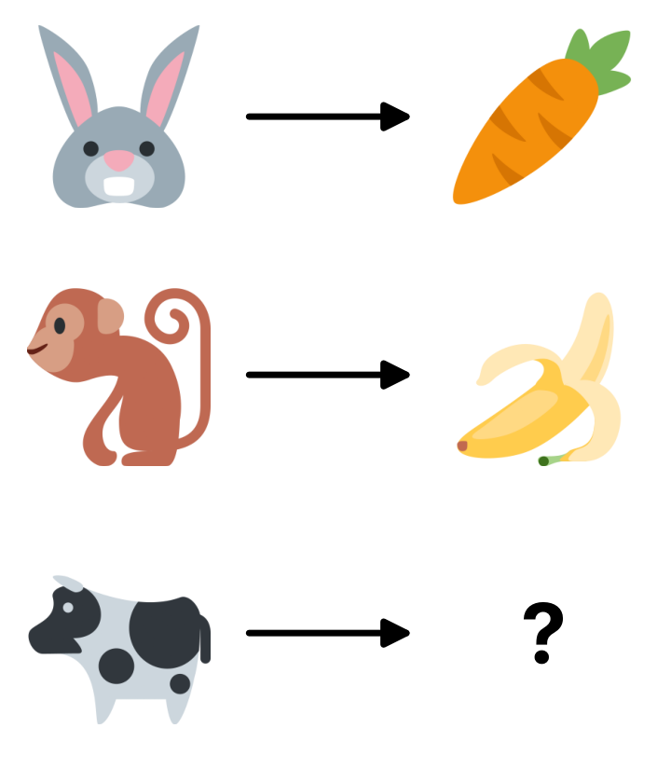
  A   | B  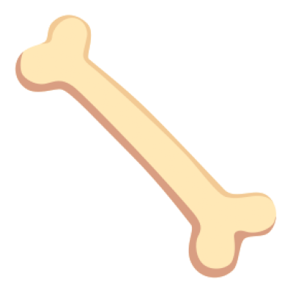
  C   | D  

Q9. Find the odd one out.
A Big – Small | B Happy – Glad | C Hot – Cold | D Up – Down

Q10. Find the odd one out.
A  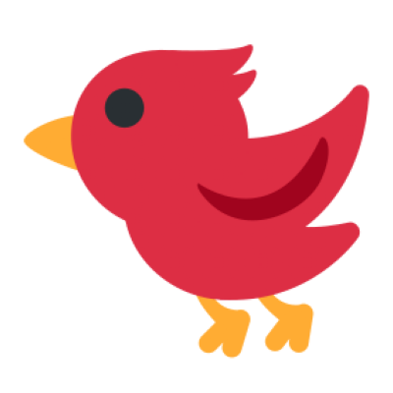 | B | C   | D  

Q11. Find the odd one out.
Note: You may turn the shapes around in your mind.
A  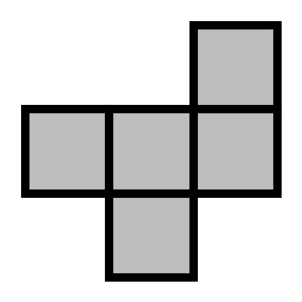 | B  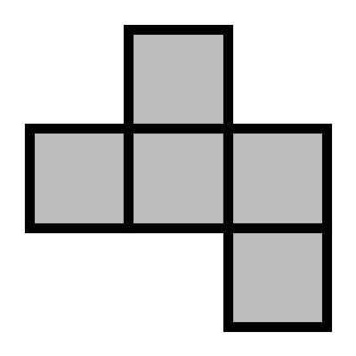 | C  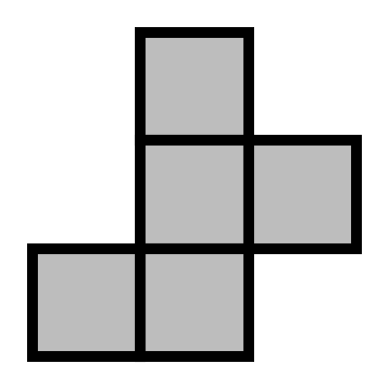 | D  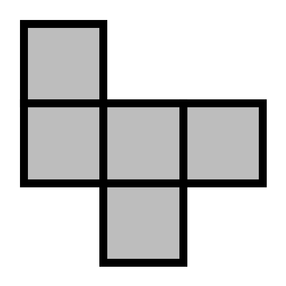

Q12. Which option is NOT a part of the question image?
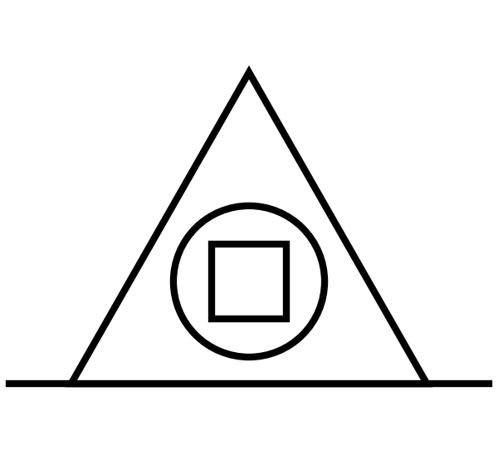
  A  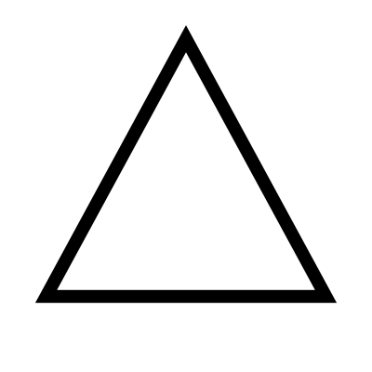 | B
  C   | D

Q13. Which of the following objects is NOT present in the question image?
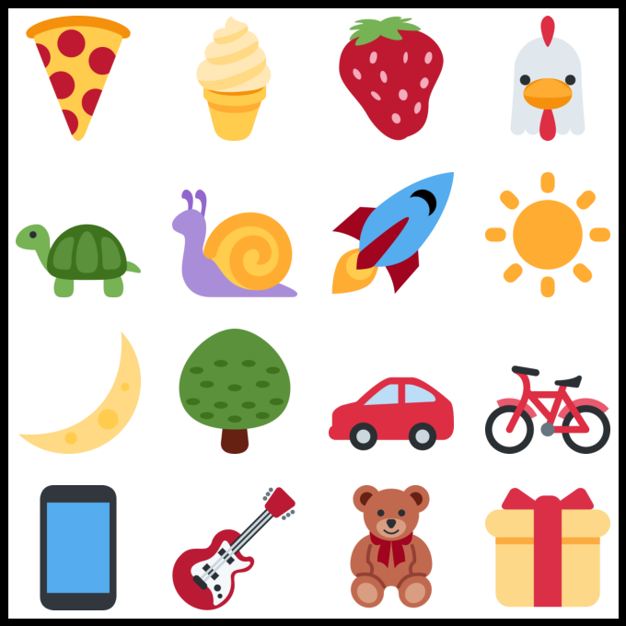
  A  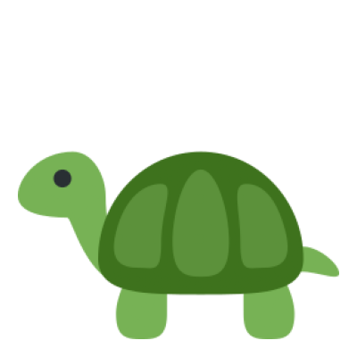 | B  
  C   | D  

Q14. Find the missing part of the image.
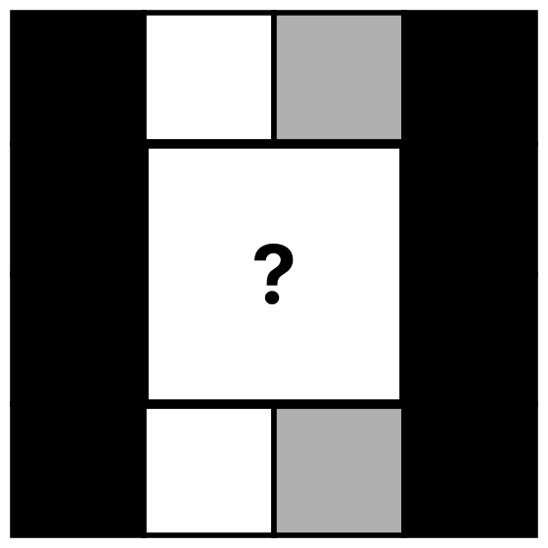
  A  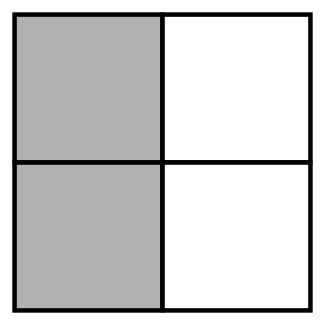 | B  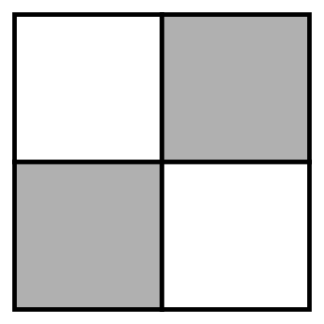
  C  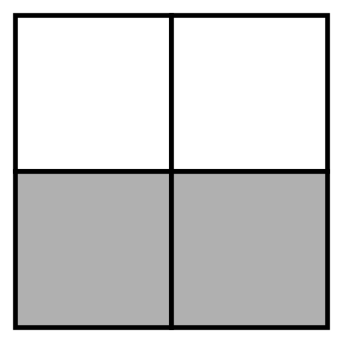 | D  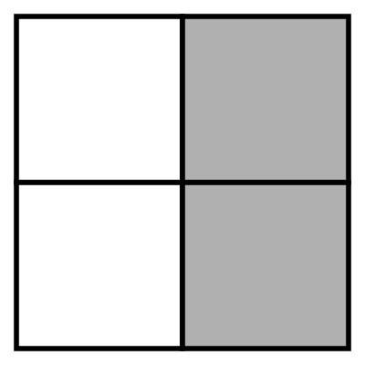

Q15. Which of the following options has the letter "A" present in it?
Note: Images in the options cannot be rotated.
A  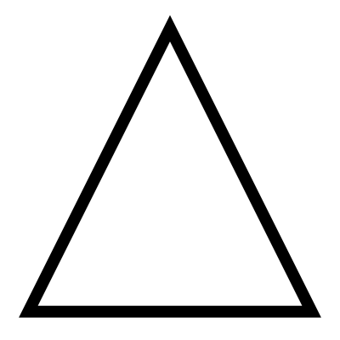 | B  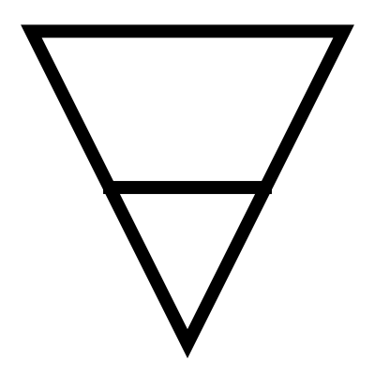 | C  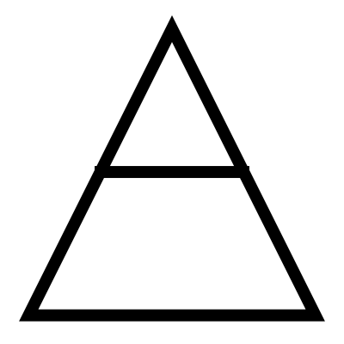 | D  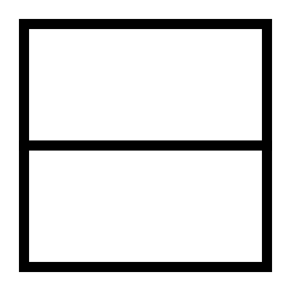

Q16. Find the missing half which is most similar to the image given below.
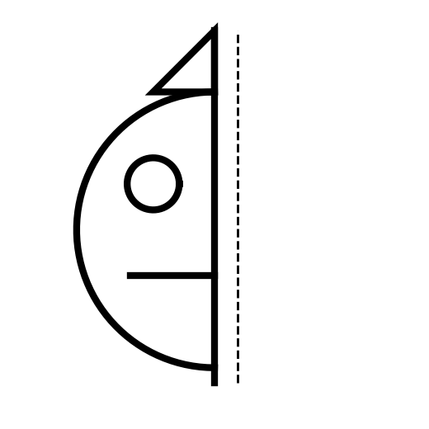
  A  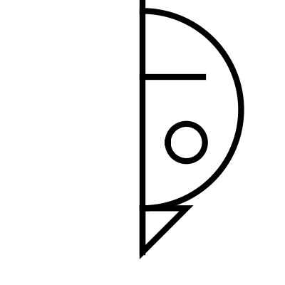 | B  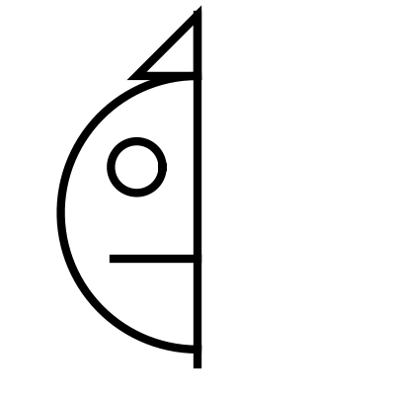
  C  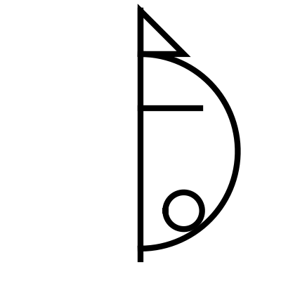 | D  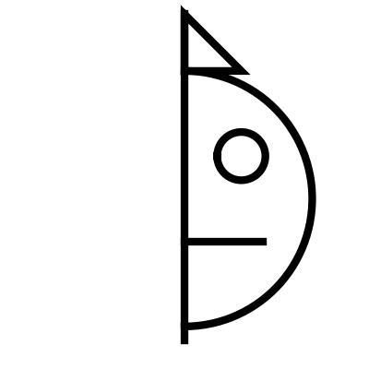

Q17. Count the number of circles in the image given below.
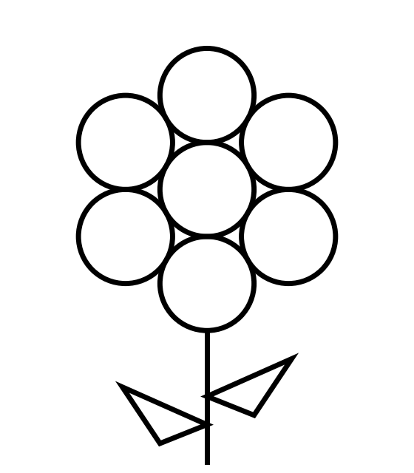
  A 6 | B 7
  C 8 | D 9

Q18. Count the number of rectangles in the given figure.
Note: Please count all the squares as rectangles for this question.
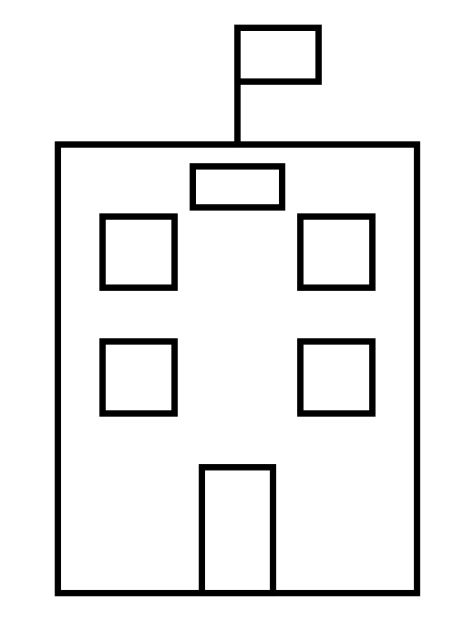
  A 8 | B 7
  C 6 | D 9

Q19. Count the number of small boxes with ONLY 1 BLACK star in it.
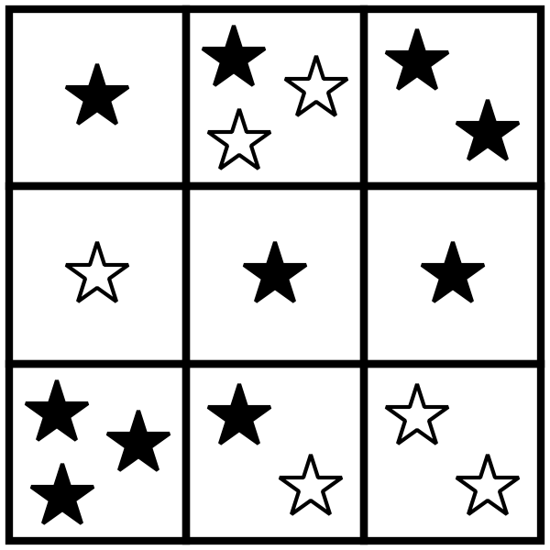
  A 2 | B 4
  C 3 | D 5

Q20. Which of the following options could be the shadow of the house given in the question image?
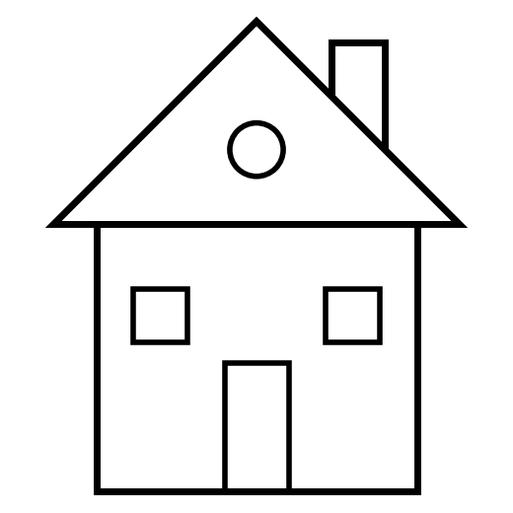
  A  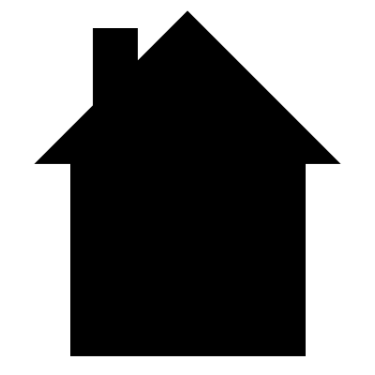 | B  
  C  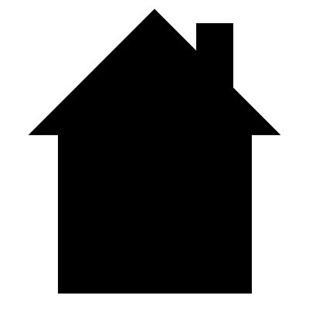 | D  

Q21. What will come in place of "?" ★ LQ Champ
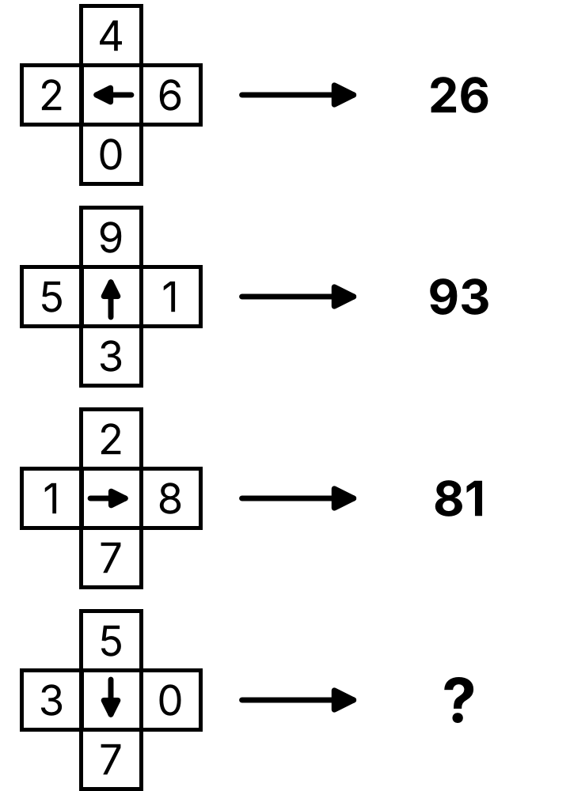
  A 57 | B 35
  C 70 | D 75

Q22. Count the number of triangles in the image given below. ★ LQ Champ
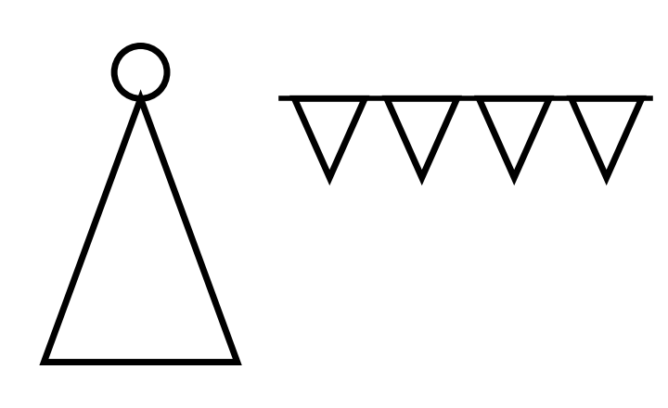
  A 5 | B 4
  C 6 | D 7

Q23. What will come in place of "?" in the given series? ★ LQ Champ
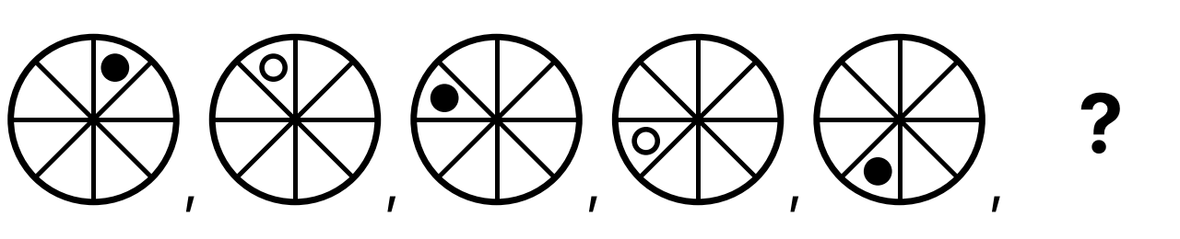
A  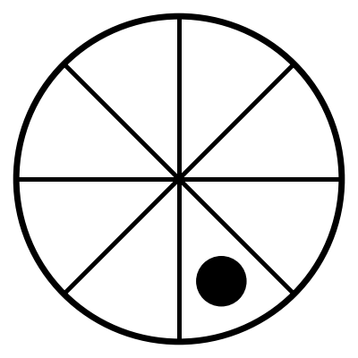 | B  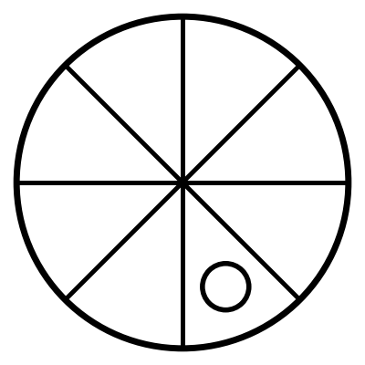 | C  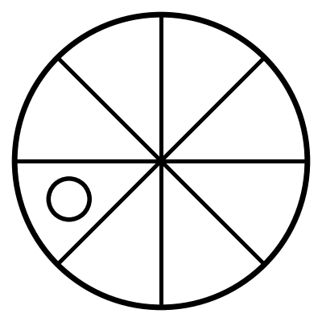 | D  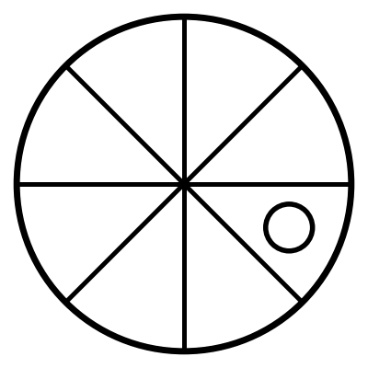

Q24. Which vehicle is NOT HIDDEN behind the wall? ★ LQ Champ
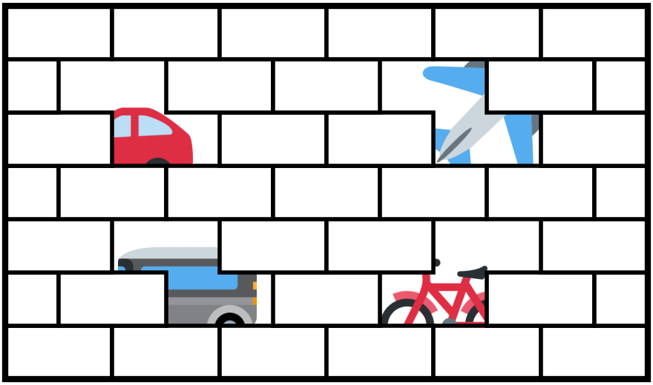
  A Car | B Bus
  C Bicycle | D Train

Q25. Which option is NOT present in the given image? ★ LQ Champ
Note: Rotation of an option image or part of it is not allowed.
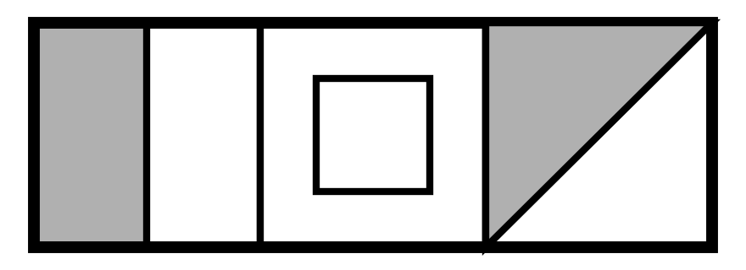
A  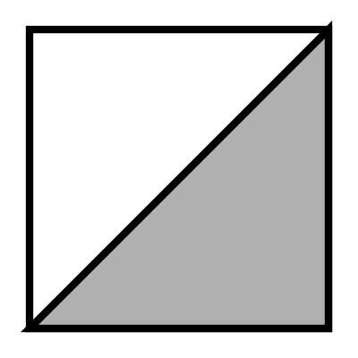 | B  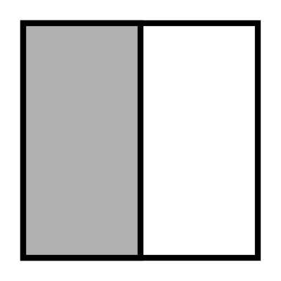 | C  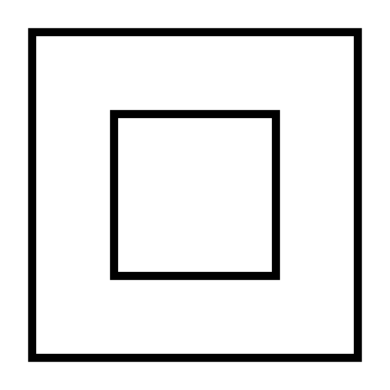 | D  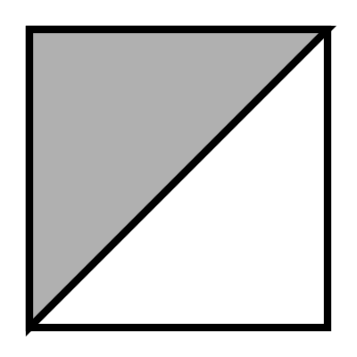

Answer Key — Assessment 3 (for parents)
Q | Answer | Why
1 | B | Both numbers go up by 1 together
2 | D | Two letters at a time in order: IJ
3 | D | Count by 2s: 10
4 | A | The letter that comes just before the two letters
5 | C | Middle (second) letter of the word
6 | C | Black becomes white and white becomes black
7 | B | Bottom-left letter → its picture top-left; top-right letter → its picture bottom-right (Dog, Kite)
8 | A | What each animal eats: cow eats grass
9 | B | Happy and Glad mean the same; others are opposites
10 | B | Fish swims, the others fly
11 | A | A is a flipped (mirror) shape, others are turned
12 | B | There is no star in the picture
13 | C | There is no doughnut in the picture
14 | D | Each column keeps its colour: black, white, grey, black
15 | C | Upright triangle with a cross line makes A
16 | D | Mirror image of the half
17 | B | 1 middle circle + 6 petals
18 | A | Building, 4 windows, door, sign board, flag
19 | C | Top-left, middle-centre and middle-right boxes
20 | C | Chimney on the right and pointed roof
21 | D | Number at arrow head comes first, then tail: 7 then 5
22 | A | 1 party hat + 4 flags
23 | B | Dot moves one step anticlockwise and changes colour each time
24 | D | Car, Bus, Bicycle and Aeroplane are hidden
25 | A | Grey triangle at bottom-right is not there

